CS 601 Midterm Exam
NAME:
2016-03-20. Your answers should be yours alone, after consulting with any written or online reference material. References that substantially influence your answer should be cited. Do NOT consult with any living sources, including professors or fellow students, and not even via the internet.

1.) Most of the content we covered this semester involve transforming one type of problem into another. Fill in the table with each transformation's source and destination problem space.
Transformation | On a machine that can solve ...  (destination problem) | This transformation will simulate ...  (source problem)
Cook's Theorem
NFA to DFA
YACC
g++ on x86
v8 on ARM

2.) Karp's seminal 1972 paper “Reducibility Among Combinatorial Problems” documents a long list of clever reductions from one problem to another. This is Karp's reduction (due to Tarjan) from Hamiltonian cycle on a directed graph, to Hamiltonian cycle on an undirected graph:
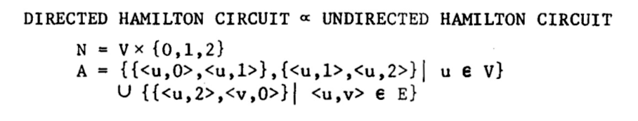
2.a.) What are N, A, V, and E?

2.b.) The generic model here is to replace each original vertex with k copies; here Karp has chosen k=3.
Please give an example of what could go wrong with k=1 or k=2.

2.c.) If it fits the hardware better, would k=4 work?

3.) Many SAT transformations use “one hot” encoding. For example, in Cook's Theorem we want the Turing machine's head to be over a single tape cell Ci, and we add a clause C0 v C1 v C2 v ... v Cn to force the head to be over at least one of our n cells. How many additional clauses does it take to force the head to be over exactly one cell in each of these cases:

3.a.) If we use clauses of the form ~Ci v ~Cj, for each pair of cells i<j?

3.b.) If we use a binary encoding for the cell numbers?

3.c.) What do the clauses look like for the case of binary encoding 4 cells, C0 through C3?

4.) Use the package CBMC to find a Hamiltonian path (not a cycle, a path) through this directed graph with 9 vertices:

struct edge {

int a,b; // source and dest vertices

};

edge edges[]={

{0,1}, {1,2}, {2,3}, {3,0},

{7,6}, {6,5}, {5,4}, {4,7},

{3,7}, {4,0}, {2,6}, {8,6}
};

#define n_edge (sizeof(edges)/sizeof(edges[0]))

Sub-steps here are to:
- Declare an uninitialized array with the vertex traversal order.
- Use __CPROVER_assume() to force the order array to contain valid vertex numbers.
- Walk the array to verify each traversed edge exists, and each vertex is visited exactly once.
- Use assume(!path_exists) to force CBMC to find and print an assertion failure.

4.a.) Copy your CBMC source code here.

4.b.) What is the vertex order of a Hamiltonian path, and how many SAT terms and clauses were used to find it?

4.c.) Can you use CBMC to check if a Hamiltonian path still exists, if you assume the second-visited vertex is not 6?

5.) How hard are each of these problems: “polynomial time”, “NP-hard”, “NP-complete”, or “uncomputable”?
Problem: | How hard? | Why? (algorithm or proof name)
Find the shortest path from one node to another in a given graph.
Find the shortest path touching each node in a given graph exactly once.
Find the shortest input that causes a given Turing machine to hang.
Find a Turing machine that will hang when provided a given input.
Find a set of node colors that makes adjacent nodes in a given graph have different colors.

