Downloading and Installing Java and TextPad

Before you can start creating Java programs, one needs a few things installed on the computer. The first is some sort of text editor (such as notepad, wordpad, Word, vi, etc.) or development environment (TextPad, JBuilder, Forte, etc. Often called IDE’s) and the second is a Java Software Development Kit (SDK). Though TextPad and Java are installed on the machines in the NT Lab (well, most of them), it is often useful and fun to work on programming at home. This help sheet will help you get set up with the basics at home, assuming that you have some sort of Windows machine. It should be noted now that various Windows machines have different configurations and so some of the pictures that you see in this help file might be different than what you see on your computer. If you have problems with this help sheet(or if you have a Mac or Linux machine), feel free to contact me and I’ll see what I can do (ftesd@uaf.edu).

Downloading the Files
The first thing we need to do is get the necessary files to download. We will need both TextPad and the Java SDK (version 1.2.2 or higher). First off, let’s get the files for TextPad. You can visit the TextPad website at www.TextPad.com and search for the download page or go directly to http://www.textpad.com/download/index.html. Once there, you will find a table of downloads that you can get in different languages. The picture will probably look something like this:
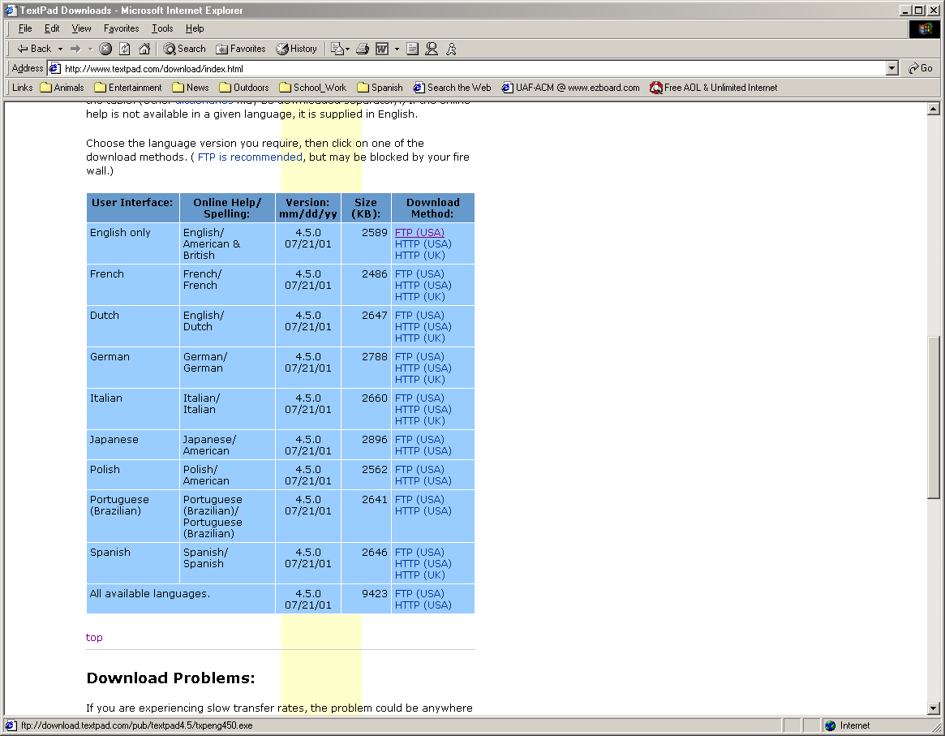

Click on any of the English versions to start a download. You will then be prompted whether you want to run the program from its current location or if you want to save it to disk. Choose “Save this program to disk.” You will then be given a Save As dialog box. I usually save downloads on my desktop, but you are welcome to save anywhere you want (but remember where you save it to! You’ll need the file in a few minutes). Once you click Save, the program will start downloading to your machine and you can move on to the next file we need to get (do not install TextPad yet! You should install Java first).

Now go to Sun’s website for java (www.java.sun.com). From there you can go find the Java 2 Standard Edition or you can just go there directly by clicking this link (http://java.sun.com/j2se/). You will then have a choice of versions to download. I would recommend version 1.3.1 but if you are worried about download sizes, you can just get 1.2.2 (down at the bottom of the page). Don’t get the 1.4 Beta version. The webpage should be looking something like this:
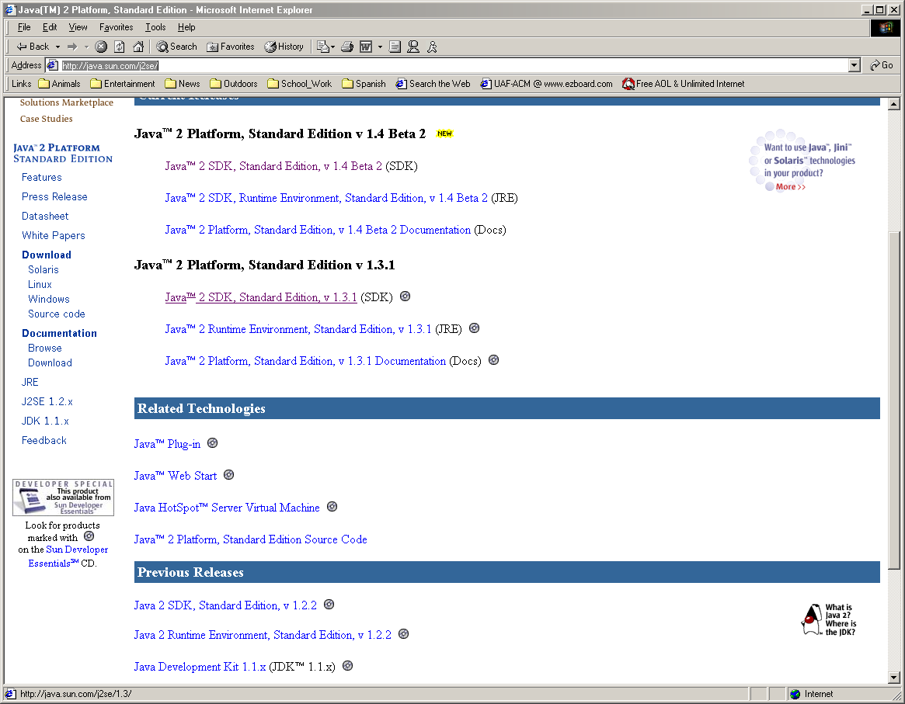

Once you click the version you want, you will be directed to a platform page that lists the various platforms that are supported by Sun (Linux, Solaris, and Windows). Click on the Windows link on the right. This will take you to a rather busy page. About halfway down the page there will be a button that says “continue” on it (it will be under the heading “Download Java2 SDK….”). Click on it. The portion of the page should look like so:
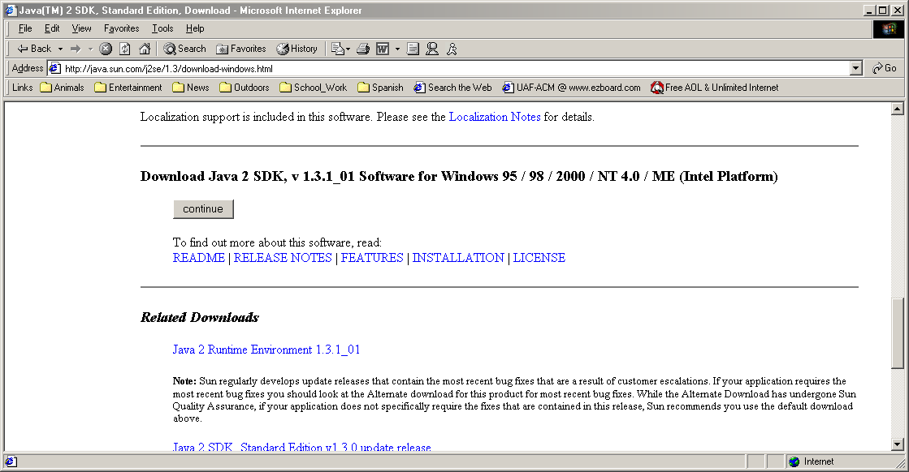

From there you will be taken to yet another page that requires you to accept an agreement to download the SDK. Read through it all (yeah right) and then click “Accept” at the very bottom of the page. Finally you will be at a download page, with lots of options to download from. Click on any one of the buttons to start a download (if one of the links fails, or is extremely slow, just cancel and try another one). Again you will be given the option to run the program from the location or save to disk. Again you will want to save to disk. Choose where to save it to (remember where you save it) and click Save to start the download. Once the file finishes saving, you are ready to begin installing the programs.

Installing
The first thing to do is install the Java SDK. So go to where you saved that file (the desktop is the usual default place) and double click on the j2sdk-1_3_1_01-win.exe file. This will start the installation. You will have to pass through a couple of screens and another agreement acceptance screen before you get to a location where you specify the directory where you want Java installed. The default is “C:\jdk1.3.1_01” currently. If you change the location, again remember what you change it to, as you might need the location in the future. The default selections for what to install are usually fine, but if you are worried about space, you can delete selections like the demos (though they are pretty cool). Keep clicking next until it starts installing files. Once it gets to the last screen just click finish. You now have Java semi-installed. To finish the installation so that you can compile, you will need to alter your PATH variable. Doing this is different on NT/2000 than it is on 95/98 which is also different than it is done on ME (which are probably all different than XP). There are some good instructions for how to do this on the Sun website at http://java.sun.com/j2se/1.3/install-windows.html#Environment. You will want to follow the directions for permanently changing the PATH variable. Where ever the instructions read <version number> you will want to put in the version number of the Java program you downloaded (currently 01). The paths that you specify for the PATH variable should match the directories where you installed your Java SDK. You should now be able to run the compiler.
To see if you have Java installed correctly, call up an MS-DOS window(go to the Start Menu and click on Run, then type “command” if you are using Windows 95/98/ME or “cmd” if you are using Windows NT/2000). Once you get a DOS prompt, type the word “javac” and press enter. If a message appears stating that you gave it a bad command name, then Java is not correctly installed (try checking the PATH variable again). If it tells you some information about the javac command, then you are ready to go. This PATH stuff can be pretty confusing, so don’t hesitate to ask if you are having problems with it.
Once Java is correctly installed, you need to install TextPad. Double click on the txpeng450.exe file that you saved to your hard disk. You will have to click next to get through the usual information screens and agreement screens. Then you will be prompted for an installation location. Once you choose this, you will be presented with a choice of what kind of installation you would like. The typical installation will be good for anything that we will be doing in CS103. Custom or compact installations have not been tested by either the teacher or the lab TA, so there are no guarantees that those will work correctly with everything. A few more screens to click “next” through and you’re done. You can now start TextPad from Start->Programs. If all is set up correctly, then you should be able to load a Java program and compile it without any errors (if you get errors about the file javac not being found, you again have a PATH problem).

Those are the basics for setting up TextPad and Java at home. If you have problems with any of these steps, feel free to email me at ftesd@uaf.edu or drop by my office (210A). I’m here to help.

